NHS England and NHS Improvement South-East
Covid-19: Delivery of Urgent Dental Care
GDP and Urgent Dental Care hub briefing
Issue No. 5 24th June 2020
Issue | Status 24th June 2020
Dental transition to recovery – survey | Thank you to those providers who took the time to complete the baseline survey which provided useful data to inform initial commissioning decisions in the support of the transition towards dental service resumption. Unfortunately, the response only generated a disappointing 75% return which provided a certain assurance, but significant gaps remained in the overall knowledge base. As a result, there is now a requirement to make a full report to Ministers with respect to dental service resumption. The update survey will also assist commissioners in understanding PPE and fit-testing provision and shortfalls, helping to identify necessary support to facilitate contractors’ transition to resuming the provision of dental services.  All contract holders are required to complete this Update Survey for their contracted sites, either providing information not previously provided, updating changed plans or confirming previously submitted data. Responses were required by close of business Wednesday 24 June 2020.  This is not a protracted survey; it has been designed to allow commissioners to identify developing service coverage, consider UDC demand and therefore provide better capacity management and identify issues that are holding up implementation of a return to dental service provision.  Here's the link to the form "Transition towards dental service resumption - Update Survey":  https://forms.office.com/Pages/ResponsePage.aspx?id=kp4VA8ZyI0umSq9Q55Ctv4T1qZrEHfRMhaiOc--tigdUMktHR1MyRFJRRTBUQUxBSjFJMTk4VlFKVy4u  The return rate to the Update Survey so far is just 43%. For those who have not yet completed and submitted the survey they will now be asked to do this under clause 211 of their GDS Contract/PDS Agreement and in line with clause 212 do this by 9 am Monday 29 June otherwise we will have no alternative but to issue a Remedial Notice as we are required to report this information to the national team for onward reporting to Ministers.
Additional Urgent Dental Care hubs? | Thank you to the practices expressing an interest in becoming UDC hubs. We were seeking additional hubs because although the number of referrals to UDC hubs has decreased as practices have opened to provide face to face care in addition to AAA, this may change periodically if there is a second wave in particular area(s). All practices have less capacity to see patients due to social distancing and cleaning requirements, particularly after an aerosol generating procedure (AGP) where the surgery needs to be left fallow for one hour before cleaning. This challenge is greater for hubs as they are now seeing their patients as well as referred patients and so to reduce the number of referrals each hub receives.  We are reviewing the expressions of interest received and once we have confirmed arrangements with the new hubs, these will be added to the Directory of Service (DOS) on the Dental Electronic Referral System (DERS).
PPE and heat; risk of heat stress | Please find attached guidance from Public Health England and the Health and Safety Executive re reducing the risk of heat stress in the warmer weather:
Fit testers required | HEE in combination with NHS England, local LDCs, LDNs and PHE are seeking expressions of interest from individuals to volunteer to train as Fit Testers for masks in General Dental Practice throughout Thames Valley, Hampshire, and the Isle of Wight.  Testers could be dentists, DCPs or non-registrants such as receptionists or practice managers.  Testers would receive 1 full day training and any testing kits and material required.  It is planned that each tester would commit to providing at least 5 days of testing at a regional centre.  Indemnity for fit testers, trained under this scheme, would be covered by NHSE employer’s public liability.  You will need to be available on 2nd or 16th July 2020 for training (further details will be supplied).  You should be able to travel independently to the nearest regional centre to carry out fit testing.  Expressions of interest should be sent to dental.tv@hee.nhs.uk  Please include your:  Name  Practice address  Occupation  No. of days per week you could provide testing
Providing AAAs for patients who have not previously attended the dental practice | We have been receiving queries about whether practices now open for face to face treatment should provide AAAs for patients who have not previously attended the practice. We appreciate this is a challenge for practices as during the initial phases of re-opening they need to focus on urgent patients and those with identified high needs whilst at the same time not having the same capacity as previously.  The position re the requirement to provide AAAs for all patients is established by national Standard Operating Procedure (SOP)  Each COVID-19 UDC system should deliver:  a remote consultation and triage service whose outcomes are: – advice, analgesia, antimicrobials where appropriate (AAA)  This has been built into the South-East SOP:  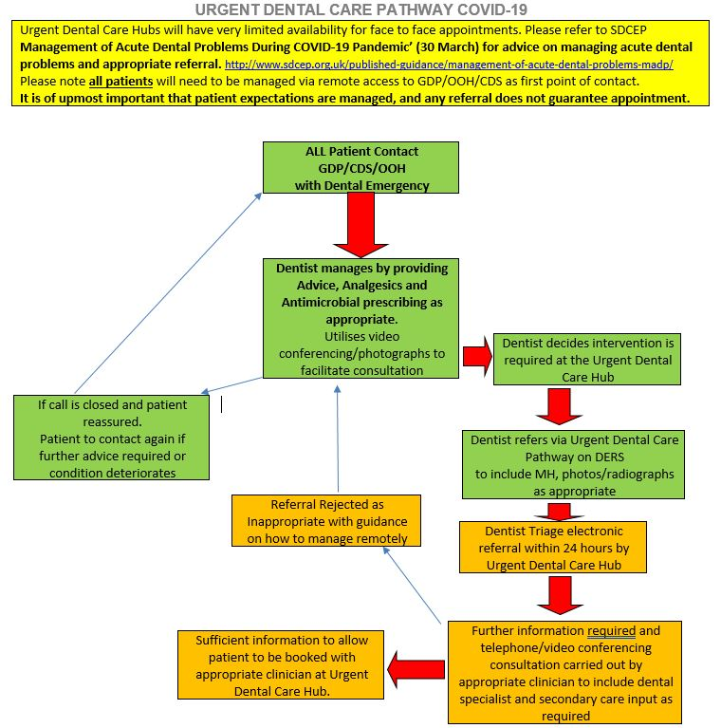  This states that …’all patients will need to be managed via remote access to GDP/OOH/CDS as first point of contact’.  This guidance has not been rescinded since practices began to re-open which means that practices are still required to provide the AAAs for any patient who contacts them.
Orthodontic extractions | Practices should not be referring patients for orthodontic extractions apart from very exceptional circumstances. They are low priority for all practices and there are few circumstances that would fit the urgent criteria to refer to a UDC hub. It is possible where an up to date assessment (post resumption of services) from an orthodontist confirms timing of the start of treatment is critical and must be carried out within x period of time and the GDS practice can’t open for even non-AGP. Extraction requests by orthodontists prior to Covid would need the orthodontist to confirm the timing of this as with backlog of care and reduced capacity, many orthodontists will now be deferring treatment starts as they need to prioritise patients that have had breakages etc during the last 3 months and catching up on all the missed assessments and debonds in that time. We should seek to avoid extractions and then patients not starting treatment for a significant period of time.

