HAMPSHIRE AND ISLE OF WIGHT LOCAL DENTAL COMMITTEE

Contact from Chair GDPC:

As you'll know MPs are set to debate the future of NHS dentistry next Thursday.

We are heartened by the hundreds of messages that have already been sent, but in this case, quantity really has a quality all of its own.

We want to ensure the widest possible spread of messages, so MPs have no excuses but to attend next week.

So can I ask you to:
- If you have not done so already send a message. Guidance from BDA staff is here. It is vital to capture your personal experience, what the current crisis means for you, your team, and the constituents you treat. https://bda.org/news-centre/latest-news-articles/Pages/England-Get-your-MP-to-speak-up-for-dentistry.aspx
- If you have sent a message, share a copy with campaigns@bda.org . Your local experiences are key and will help staff as they continue to lobby MPs.
- Encourage others to have their say. Whether your LDC or other local networks.

This debate was granted on the last afternoon before MPs go off for half term recess, and for most MPs attending this debate means staying in London an extra day just to speak in it, so we need all the help we can get in motivating them to stick around for it.

We have helped secure a major debate on access to NHS dentistry* in Parliament – this has just been scheduled to take place on Thursday 10 February 2022 at 1.30-4.30pm.

I don’t need to tell you that colleagues across England are under unprecedented pressure. Please, can you write to your MP and ensure they speak up for this service, and patients that depend on us?

Just enter your post-code and you can get your MP’s email address.

Find your MP

5 things to consider

Your story can be powerful. Show how the crisis this service now faces is impacting on your practice and the patients you treat:

- We face an access crisis. Over 38 million appointments have been lost since lockdown, and oral health inequality is set to widen. Explain what you're seeing, and how you are struggling to deal with an unprecedented backlog.
- Dentistry is hanging by a thread. An exodus is in motion. Morale is at an all-time low and many dedicated NHS colleagues are now looking to the exit.
- We need real reform. Dentists are working to a contract that punishes colleagues – 12 years after it was promised, we need to finally see a contract that recognises and rewards commitment and prevention.
- We can't rebuild the service on an ever-shrinking budget. The government has just offered £50 million in time-limited funding. This is no more than a sticking plaster. After a decade of savage cuts, we need fair funding to underpin a new system.
- Get them to take action. Ask your MP to commit to attend and speak up about this in Parliament on 10 February at 1.30pm.

When emailing your MP you must include your postcode, and please copy in campaigns@bda.orgso we can follow this up with them on your behalf. Please do also get in touch by replying to this email if you need any advice, guidance, or data on your local area.

We’re keeping up the pressure in Parliament and the press.

Please help us make sure your voice is heard.

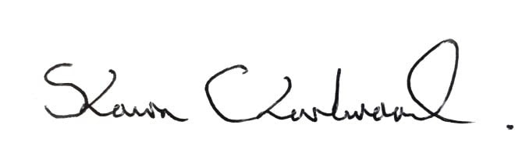

Shawn Charlwood
Chair, General Dental Practice Committee

*If you are not currently delivering NHS dentistry please update your details.

