# **Hampshire & Isle of Wight Local Dental Committee**

**Committee Meeting – Wednesday 11 September 2024 at 7pm**

**Venue: Chilworth Manor Hotel, Southampton SO16 7PT**

**Part One**

1. **Welcome** – The Chair welcomed all to the meeting. He welcomed Jessica Patel-Barnes as the new Vice Chair.
2. **Present*:***Phil Gowers (Chair); Claudia Peace (Treasurer); Keith Percival (Secretary);Jessica Patel-Barnes (Vice-Chair); Parimal Manek;Sham Seehra;Nick Forster; Emily Vidovic – Website/Media Manager and administrator- in attendance); Lauren Holmes; Caroline Frolander; Nerina Hendrickse; Lloyd Payne; Caroline Short – minutes

**Apologies:** Shilpa Chitnis; Eva Lewin; Hardev Seehra; Patrick Stewart; William Creedon; Katie Kerr; Kim Jones; Janita Dhariwal

1. **Conflicts of Interest – Not already declared -** None

1. **Minutes of the Meeting** 17 July 2024 (Part One) signed off as a true and accurate account of the meeting.
2. **Matters Arising from the minutes and not on the agenda**

PG Cert Conscious Sedation 2 cohorts to date. Available to two internal candidates / private / NHS / CDS others ICB have asked for expressions of interest which will be funded.

NF – In the main sedation is available via the private route due to the associated costs, no additional UDAs for this type of treatment.

PM – Confirmed that the Oral Surgeon receives a small additional fee when using sedation during treatment.

PM - Raised concern with the number of accronyms that are used within the minutes and reports of the LDC.

NF – Suggested that it would be useful to produce a list. However, many can be googled.

NH – Always able to ask for guidance and questions

1. **NHSE Workforce Training and Education Report** – Katy Kerr by e-mail

**Summary NHSE Workforce Training and Education (formerly Health Education England) Report September**

**2024**

* Continuing to work with LDNs, MCNs and ICBs to develop appropriate training opportunities for the whole dental team. In discussions with ICB and CDS to look at setting up Child Focused Dental Practices. An in-depth briefing report has been sent to the NHSE Executive Regional Managing Director (South), Anne Eden, on the Dental training programmes and workforce planning to support dental service provision in order to fulfil the NHS Long Term Workforce Plan.
* HEE folded in to NHSE in April 2023. Will move to align Dental with Kent Surrey and Sussex to work across the South East. This process is still under review and will take longer than first envisaged with an unknown structure or timeline at present.
* We have run a series of events to highlight career choices in oral health with both primary and secondary school pupils. Currently in discussion with ICB and Hampshire College Group around apprenticeship delivery. Eastleigh College are starting a Dental Nurse apprenticeship in September and NHSE WT&E are looking at ways to encourage uptake and develop the OHP apprenticeship.
* NHSE Professional Standards Team manage the process for International Dental Graduates to work in the NHS and gain their performer list number. NHSE WT&E have updated the Introduction to NHS webinars to fit the new programme and held a training session to support Mentors.
* We currently have 62 DFT & 6TFT and 4 JDFCT (2-year longitudinal posts to combine DFT and DCT1). 2 Academic FD posts were filled.

Model – split week. Year 1 GDS/CDS. Year 2 GDS/CDS/ Maxillofacial &/or Oral surgery input. Started 2 more posts to include Ortho rather than CDS. Will look to introduce 8+8+8 in future. Practices have dropped out at short notice, so only just covered all trainees. We are undertaking some events to encourage applications for next year.

* Due to the reduced number of Therapist Trainees, we are utilising the funding to upskill Therapists who have predominantly been delivering hygiene services via a Return to Therapy Course (RTT). We are currently also running a bespoke RTT for international dental graduates who have registered with the GDC as Dental Therapists.
* The Dental Nurse Forum continues with the aim to support retention and career development.
* The Dental Therapy Forum has been set up to support Direct Access and we will be offering **an in-person practice event on 14th November 7-9pm** to help understand how to utilise a Dental Therapist working in the NHS in November. Looking to provide training to comply with new HMR legislation and provide access to national resources (details will be circulated).
* In addition: **Supply and administration of medicines by dental hygienists and dental therapists - Free live webinar**
* **Tuesday 24th September 2024 6:00pm – CPD 1 hour**
* This webinar will cover aspects that may need to be considered by contractors, dental hygienists and dental therapists to determine whether working to exemptions will improve clinical efficiency and patient care in practice. It will outline the steps that contractors could be taking (prior to the recommended training) to prepare the dental team to work to exemptions if it were deemed necessary.
* Speakers will be sharing their perspective and lived experiences about working to exemptions.

**Register for this event:**

[https://accent.hicom.co.uk/CourseManager/Live/HEE/Web/sys_pages/Course/CourseEventInvitation.aspx?FilterCourseEventID=f42a68b9-a2ea-43ff-b124-3f469f843e68](https://gbr01.safelinks.protection.outlook.com/?url=https%3A%2F%2Faccent.hicom.co.uk%2FCourseManager%2FLive%2FHEE%2FWeb%2Fsys_pages%2FCourse%2FCourseEventInvitation.aspx%3FFilterCourseEventID%3Df42a68b9-a2ea-43ff-b124-3f469f843e68&data=05%7C02%7Ckaty.kerr1%40nhs.net%7Cfb07a67da5004a88dd9208dcd0c58d50%7C37c354b285b047f5b22207b48d774ee3%7C0%7C0%7C638614794106900618%7CUnknown%7CTWFpbGZsb3d8eyJWIjoiMC4wLjAwMDAiLCJQIjoiV2luMzIiLCJBTiI6Ik1haWwiLCJXVCI6Mn0%3D%7C0%7C%7C%7C&sdata=xvJdOaJPTTbZuo%2BahfKEwkIsmwQLzJygRWrQe4K2xHM%3D&reserved=0)

Guidance on the implementation of working to exemptions for dental contractors, dental therapists and dental hygienists will be published shortly on:

[https://www.england.nhs.uk/publication/guidance-on-the-implementation-of-the-supply-and-administration-of-medicines-by-dental-hygienists-and-dental-therapists-for-dental-contractors/](https://gbr01.safelinks.protection.outlook.com/?url=https%3A%2F%2Fwww.england.nhs.uk%2Fpublication%2Fguidance-on-the-implementation-of-the-supply-and-administration-of-medicines-by-dental-hygienists-and-dental-therapists-for-dental-contractors%2F&data=05%7C02%7Ckaty.kerr1%40nhs.net%7Cfb07a67da5004a88dd9208dcd0c58d50%7C37c354b285b047f5b22207b48d774ee3%7C0%7C0%7C638614794106919108%7CUnknown%7CTWFpbGZsb3d8eyJWIjoiMC4wLjAwMDAiLCJQIjoiV2luMzIiLCJBTiI6Ik1haWwiLCJXVCI6Mn0%3D%7C0%7C%7C%7C&sdata=LgmdJHkUTD7bUiX6KCCtZuiBx%2FpRupFQzjS5dir3ixk%3D&reserved=0)

1. **NHS England, H&IOW ICB Update**

No separate report - areas highlighted in Secretary’s report circulated. Alison Cross attended the recent LDN meeting. KP requested a report but to date nothing has been received.

1. **Other NHS England - South Region (Wessex) Reports**

**LDN**

Local Dental Network (LDN) set up in last NHS reforms. Dentist led to advise NHS England commissioning. Managed Clinical Networks (MCN) report to the LDN these unfunded groups were set up to improve Dental services. LDN tries for advise on clinically led commissioning but struggles to be heard.

Recent contract hand back West Isle of Wight, will not be commissioned at a higher rate. Need to attract performers into the system. Suggested way forward might be first two years of contract at a sessional rate due to the high need then move onto a UDA payment system.

Currently there are seven contracts being commissioned in Portsmouth, Southampton and the Isle of Wight. Huge variation of flexible commsssioning across the country. Areas (nationally 42) of the local Integrated Care Board (ICB) are restricted. Some contracts are offering fewer UDAs for the same money and some are commissioned to provide 4 hours of urgent treatment via 111. Contract set up needs changing due to the high need of urgent appointments.

Early into his new position Wes Streeting, Secretary of State for Health and Social Care, met with the BDA. BDA highlighted that there is an urgent need to change the dental contract. In 2009 Jimmy Steele, Prof at University of Newcastle undertook a review and stated that UDAs were brought in as a temporary solution in 2006. During the contract review and ensuing pilots/prototypes there were two suggested ways forward Blend A) 60% and Blend B) 83% capitation. Waiting on decision from Government how future contract reform will proceed

ICBs control the money, NHSE refer to ICB for approval and funding.

PM – suggested talking to the H&IOW ICB Clinical Director.

Dorset, Berkshire, Oxford, Buckinghamshire and Norfolk ICBs are onboard and considering more flexible commissioning.

NF – To attract the workforce you need to get a contract that works.

The ICB appears to be keen to have a dental school in the area ( unknown whether it will have full dental school status) evidence suggests that qualified Dentists tend to stay in the area where they qualified.

In 2006 there was approximately £3.2 billion spent on dentistry, in 2022 this has only increased to £3.3 billion despite increasing costs.

KP – Government is aware and ask the question why the money is not always spent.

NH – Many practices are now mixed offering private and NHS – Private treatment props up the NHS

KP – Nationally there are 42 ICBs with 42 different ways of working. Many feel that they are not listening to those that have the necessary knowledge and understand the NHS primary care provision issues for example local representative committees.

PG – Recently attended (with the Secretary) a Primary Care Working Together Meeting where the the main topic for discussion was to review what was working well in different areas across the South East. The first signs were encouraging.

NH – Concerned that there is a lot of information / data held with a variety of groups, but it is not being flagged in the correct place.

PG – Confirmed that there is a follow up meeting planned.

**Oral Surgery MCN – report to the LDN by Helen Spencer**

**DERS**

The issues are recorded in the MCN outcomes below

**MCN Chairs Meeting**

The main issues are:

Surgical waits, particularly for paediatric surgery. The multiple waits for paediatric orthodontic patients who may require onward referral to secondary care and then to surgery were a particular concern.

Local initiatives between the PHUT oralsurgery/orthodontic team, NHS Solent and UHS OMFS have reduced the waiting time for both paediatric dentoalveolar surgery consultations and the wait for surgery in Portsmouth and Southampton and is now at or approaching pre-pandemic waits. This has been an exceptional piece of work recognised by GIRFT.

The large number of referrals for TMD. Mainly from GDPs, but also from GPs who do not use the NHS guidance. Any help on how this can be shared locally would be appreciated.

**MCN meeting**

Again we have received limited feedback from the LDN. For example

actions following the REGO meeting?

We have still not received any updates following meetings in 2023 about updates to the system.

The plan was that the GDP teaching would be tied in with these updates.

For LDN action:

When can we expect action on the updates agreed at MCN/NHSE/LDC meetings? The MCN teams have put a significant amount of work into this with no outcome.

Has the update to the postcode database that Rego advised happened?

Is live chat no longer funded?

**Tier two accreditation**

Non specialists are providing iMOS services in Hampshire and IOW.

Historically:

The MCN is unaware of the contractual arrangements commissioned. The MCN, at the time of commissioning, agreed that if non-specialists were to provide treatments, the specialist should be onsite or available to address any concerns without an additional appointment being required.

We are aware that a level 2 contract was awarded, but the MCN is unaware of the details.

The MCN was informed that special arrangements were made for the IoW.

The current providers of an iMOS contract have been advised that non-specialists cannot provide treatments.

The MCN believes that in 2024 the current situation requires action to demonstrate equity for providers, recognition of long-term performers and quality assurance for the patients.

The MCN chairs have agreed nationally that transfer of accreditation of non-specialists is currently not acceptable.

The MCNs preferred option is for accreditation of non-specialists.

To expedite this a pilot process to review the portfolio and practices of current non- specialists and of the number required to provide the current service to allow them to deliver care until the end of the current AQP contract.

In addition, current performers without a performer number could be supported to obtain a performer number limited to oral surgery.

Issues arising from MCN members:

Some patients seen in adjacent areas have been advised that as they are considered cross border referrals despite being seen by their closest provider, they are required to pay privately for iMOS treatment – has there been any action on this?

Second request for education meeting – especially valuable for iMOS providers who do not also work in secondary care. It was agreed this was in the best interests of the service. Is there funding available for a face to face venue please?

Again, it was confirmed that funding for this process should be available from the CCG to LDN. Funding for support to request and collate the information from non-specialists and also to enable the panel to be indemnified. When I asked in the spring, this was not thought to be necessary. Are there any changes to the LDN’s position?

**Orthodontics MCN –** Ross McDowall by e-mail

Next meeting due 13 November 2024

Following the Basingstoke consultant relocating to Portsmouth Basingstoke are experiencing difficulties with referral received. New consultant due on a one year fixed contract. High numbers of referrals coming into all areas.

**Salaried Service & MCN –** Caroline Frolander

**Referrals Received / Referrals processed in month**

Starting to see a trend of decrease in accepted referrals

Approximately 5800 patients waiting.

Waiting times vary across service 8-34 months

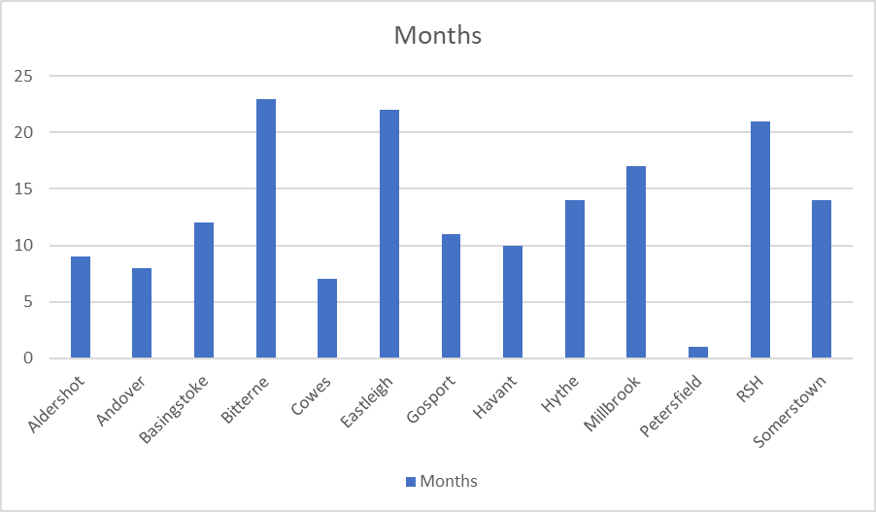

**GA Waiters**

Waiting times increased - Average wait 14 weeks

Adults           Longest wait 85 weeks 113 patient waiting

Children      Longest wait 61 weeks   255 patients waiting

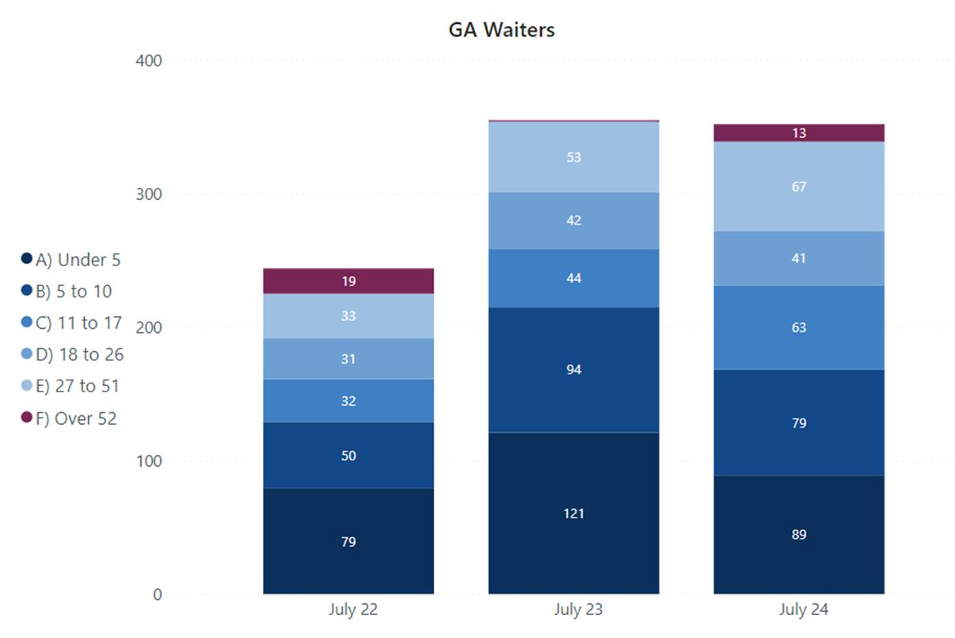

**Workforce**

9.2 wte dentist vacancies 3 recent part timers recruited for North Area

1.2 wte dental therapist vacancies 0.2 recruited for IOW

**Tender**

Comments on latest version submitted to NHSE mid August

MCN chairs requested to review version 27 of the proposed service specification and feedback. Currently rigidly enforcing current service specification eg Domiciliary visits only being offered to those who are bedbound or have challenging behaviour and it is too dangerous for them to be brought into clinic, aligning with the GP definition for a home visit.

Workstream ‘child focused’ dental practices. ICB to apply for funding for this pathway. Less complex children who do not require special care. Huge number of children sat on waiting list for high need or time. Special care to support. Katy Kerr coordinating theortetical. Anticipated in 2026 there will be four pilot practices. Supported with equipment eg stainless steel crowns along with shared care if needed. ICB need ideas of how GDPs could be renumerated. Jo Tomlinson very positive, but the commissioning hub is bound by rules. Considering an enhanced UDA rate as they cannot monitor a sessional rate. Might cost more initially, more than just numbers, ways to look after staff, looking at the future / wider picture. Group keep challenging.

Ready to launch Direct Access, Dental Therapists currently working to a prescription set by the Dentist. Direct Access will mean they are able to Exam and set a treatment plan. Mentoring in service to cover competencies prior to going solo.

CSF highlighted a recent incident with learning to be shared.

Child who had waited under 2 years to be seen by special care service, during which time he was being monitored checked by his GDP. Referred in for caries in deciduous teeth, compliant for bite wings. Showed 3 6’s erupted but no professional curiosity on where the 4th 6 was. Dental Therapist took bite wing which showed angulation of upper pre-molar, DPT taken which showed a massive abonoamlity in mandibular benign odontotumour. Nothing in the dental electronic referral system (DERs) to record / review whether development is correct at this time (age) eg Is the dentition as you would expect?

This is very rare but does happen. Learning poster to be added to the LDC website.

1. **University of Portsmouth Dental Academy Report** – Kim Jones by e-mail

**UPDA Report on behalf of the Executive Leadership Team 11/09/2024**

1. The Clinical Directors are concerned about the recent change in acceptance criteria for bariatric patients. Solent now only accepts patients weighing over 30 stone which poses a challenge for us at the DA, as our chairs a weight limit of 21.2 stone. Can Caroline provide clarity on the referral process for patients weighing between 21.2 and 30 stone?
2. We urgently need to secure additional placement venues for our Level 4 dental nurses, as our cohort has grown to 41 this year, and we are facing a significant shortage. If you are able to assist, please contact Sue Fenton (sue.fenton@port.ac.uk) or Jane Cuthbert (jane.cuthbert@port.ac.uk).
3. I have also been asked to highlight our upcoming in-person CPD course. In November, we will be offering the following course.

TOPICAL FLUORIDE APPLICATION FOR DENTAL NURSES Friday 1st and Saturday 2nd November 2024, 9.00am - 4.45pm Cost: £375.00

This two-day course in fluoride varnish application provides qualified, registered dental nurses with an educational experience in knowledge, critical understanding, intellectual skills and practical skills.

This course will enable you to provide effective fluoride varnish application within a community-based programme and/or on prescription from a dentist or as part of a structured dental health programme.

During this course you will:

* be taught the safe practical application of fluoride varnish
* learn the contraindications to applying fluoride varnish
* learn how to communicate with patients regarding the application of topical

fluoride and gain the appropriate consent

* understand how to be prepared to communicate effectively with patients,

parents, carers and colleagues with different social and cultural backgrounds and with different care needs

page1image9328528

You'll be taught by Debbie Withers, Senior Dental Care Professional Teaching Fellow, University of Portsmouth Dental Academy

Kim Jones

1. **BDA Report – Nerina Hendrickse**

No report

Highlighted the need for new members.

1. **Any Other Business**

JPB – highlighted an forthcoming issue in the next month there will only be one supplier of amalgam in the UK.

PM – Rajiv Anand, Oral and maxillofacial surgeon at QA Hospital Portsmouth, passed away suddenly on 27 July 2024. The LDC will recognise his valued contribution to patient care over many years and send a card of condolence.

1. **Dates of next Meetings**: 6 November 2024; 15 January 2025; 19 March 2025 tbc